|  |  |
| --- | --- |
| Assessment Title | Update and secure the API |

## Competency Details

|  |  |
| --- | --- |
| Unit code/s and title/s | ICTPRG553 – Create and develop REST APIs |
| Qualification code/s and title/s | ICT50220 Diploma of Information Technology |
| Business unit/Work group | Business and Arts/IT Studies |

## Instructions

|  |  |
| --- | --- |
| Method/s of assessment | Questioning (Written)  Product (JavaScript Code)  Product (Screenshots as evidence) |
| Overview of assessment | This assessment will require you to:   * Complete written questions within this document * Provide screen captures for written questions within this document. * Complete JavaScript code for API development |
| Task/s to be assessed | This assessment will require you to complete the following tasks  Task 1 – Update the API endpoints for CORS and pre-flight with OPTION  Task 2 – Select an API client and test CORS |
| Time allowed | Refer to your schedule for submission dates |
| Location of assessment | Assessment can be completed anywhere with access to the resources required. (See Resources Required section below) |
| Decision making rules | To receive a satisfactory outcome for this assessment you must complete all parts correctly.  Word counts are provided as guidance only. |
| Assessment conditions | This assessment must be undertaken where conditions are typical of a work environment requiring cyber secure practices, processes, and procedures.  This is an unsupervised assessment, and you may access any required resources. |
| Resources required | To complete this assessment, you will require the following:   * Visual Studio Code * Internet access * Microsoft Word * Microsoft Windows 10/11 * Node.js * AdonisJS * ICTPRG533 - ASDS – Policy ID 191 - Rapid Application Development   You can complete on your own computers or laptops if you are able to source the above requirements. |
| Result notification and reassessment information | You will be provided feedback and the result for your assignment on TAFESA Learn. You will be and given the chance to resubmit with required corrections only once.  Refer to the TAFE SA assessment policy for more information <https://www.tafesa.edu.au/apply-enrol/before-starting/student-policies/assessment> |

**SCENARIO**

You have been employed by the ITWorks organisation as a junior programmer and you have previously done some work with JavaScript. A client has come to ITWorks with a large project which has a short time frame for completion. This project is a student enrolment system where students can register themselves into their studies using a web application.

This sort of application will be back end heavy as a great deal of data will be stored and retrieved from back-end systems.

ITWorks senior developers believe that an Application Programming Interface (API) would be valuable for this project for retrieving backend information and you have been tasked with doing some preliminary research and implementation for the enrolment system API. The work that you do will be built upon in the future should the client and senior developers be happy with your results.

Your ITWorks team has some experience already with JavaScript frameworks and are interested in using AdonisJS and Visual Studio Code for more projects moving forward. Visual studio code has been highlighted for the ability to add extensions, the excellent JavaScript language support, and the ability to connect projects to GitHub for collaboration.

**Task 1: Update the API endpoints**

Using the API and endpoints created in Assessment 1 complete the following tasks.

**Question 1:**

Update your /students/{id} API endpoint which implements the GET method with an error message if the student id does not exist.

Provide the JavaScript file you created to implement this endpoint for submission.

**Question 2:**

Update your API endpoint /students which uses POST to include an error message if the student already exists.

Provide the JavaScript file you created to implement this endpoint for submission.

**Question 3:**

Update your API endpoint /students/{id} which uses PUT to include an error message if any of the updated fields are blank. Provide the JavaScript file you created to implement this endpoint for submission.

**Question 4:**

1. Update your API endpoint /students/{id} which uses DELETE to include an error message if the id you have provided does not exist. Provide the JavaScript file you created to implement this endpoint for submission.
2. Will updating your endpoints to include error checking affect the schedule or project plan that ITWorks management has outlined?

**Question 5:**

Modify your project cors.ts file so that cross-origin requests are enabled. Show the code and explorer panel with file names visible in a screenshot below.

Screenshot of CORS enabled:

**Task 2: Select an API client and test CORS**

**Question 6:**

We need to review and select an appropriate API client for our upcoming testing of the API. Refer to the [Postman website](https://www.postman.com/product/what-is-postman/) and the ITWorks policy document, ICTPRG533 - ASDS – Policy ID 191 - Rapid Application Development, for information about the software and for the policy on supported ITWorks API Clients.

Provide a description of the ITWorks supported API client. Include its name, what it is and what it allows you to do with your API (50 words)

**Question 7:**

Using your web browser and the developer tools make a GET request to your API and show that simple CORS is working correctly.

Screenshot of console window:

Provide a screenshot of the response headers:

**Question 8:**

Modify your project cors.ts file so that CORS pre-flight requests are allowed and configured. Provide a screenshot of your code with filenames and the code visible in your screenshots.

Screenshot of origin set:

Screenshot of allowed methods:



Screenshot of allowed headers:

Screenshot of exposed headers:

**Question 9:**

* 1. Using your web browser and the developer tools make a POST request to your API by adding a new student to your endpoint /students and show that simple CORS is working correctly. Include screenshots below showing the necessary details about your request.

Screenshot of browser window including URL and endpoint:

Screenshot of developer tools including appropriate preflight headers:

Screenshot of console window showing no error messages for CORS:

* 1. List two features of the OPTIONS method

1. The OPTIONS method is often used in the context of CORS to determine whether a specific request is allowed from a different domain. The response to an OPTIONS request includes the CORS headers that indicate which origins are allowed to access the resource

2. The response to an OPTIONS request can include metadata or links to documentation resources that describe the available endpoints

**Question 10:**

We now need to test the endpoints that we have created. Using the ITWorks supported API testing client, test all your endpoints, and provide screenshots of the successful responses in the client.

* + - * 1. Screenshot of using endpoint /students which retrieves all the students currently registered:

* + - * 1. Screenshot of using endpoint /students/{id} which retrieves a single student from the system using a studentID

1. Screenshot of using endpoint /students which adds a single student to the system using a studentID

1. Screenshot of using endpoint /students/{id} which edits a single student using PUT from the system using a studentID

1. Screenshot of using endpoint /students/{id} which edits a single student using PATCH from the system using a studentID

1. Screenshot of using endpoint /students/{id} which deletes a student with a given id.

1. ITWorks management has been impressed with the API project so far. ITWorks has many entities in the enrolment system database that would benefit from being added to the API such as:

* Lecturers
* Classrooms
* Subjects
* Schedules
* Grades
* CRN’s
* Student Plans

Will creating endpoints for all these entities affect the schedule or project plan that ITWorks management has outlined?

**Question 11:**

As per the policy, ICTPRG533 - ASDS - Policy ID 192 - ITWorks Organisational policies and legislative requirements, ITWorks has legislative responsibilities regarding users' privacy and data usage. As such, ITWorks would like authentication and authorisation added to all API’s developed by ITWorks.

* 1. Provide a description of the AdonisJS API Token authentication system for API’s (50 words)

AdonisJS API Token authentication system allows users to obtain a token after successful authentication, which is then used for subsequent requests. The system validates the token to ensure authorized access to the API's resources.

* 1. Provide an explanation as to if this is an appropriate method of authentication for your API and if it is compatible with your project (30 words)

This method of authentication is appropriate as it will allow you to

**Question 12:**

ITWorks has asked that you implement the API Token authentication with your API project. Add API Token authentication to your API and provide the following screenshots:

Screenshot of adding the authentication package to your project:

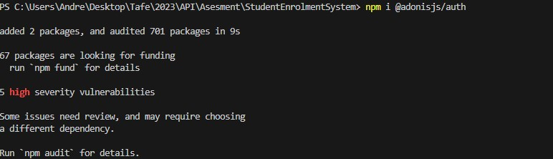

Screenshot of the command to start configuration:



Screenshot of configuring api token authentication with database storage:

Screenshot of successful configuration:

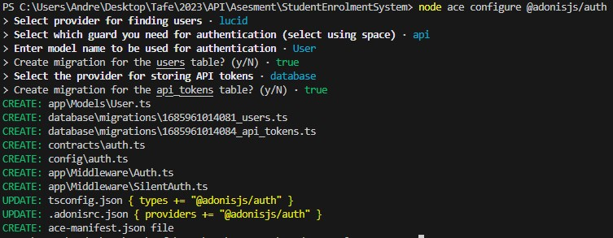

Screenshot of command to run the migration and the success message:

Screenshot of modifying the user model:

Screenshot of creating the Auth Controller:



Screenshot of defining user routes:

Screenshot of modified routes.ts file:

Using Postman, screenshot a successful test of logging into your API:

**Second API Application Submission:**

You are required to upload 2 files to Learn for your submission for assessment 2:

* Zip file of your entire StudentEnrolmentSystem API project with all project files included and named ***StudentEnrolmentSystemPart2_YourIDNo.zip***.
* Word document containing the screenshots and answers to the written questions listed in this assessment document. The answer document should be named ***Assignment2_YourIDNo.docx***.